CO1 Concept Map Assessment
B.Purna Kishor Reddy
192472171

5. Create a concept map linking tokenization and embeddings with the operation of Large Language Models. Starting from raw text, show how text is converted into tokens and numerical representations and explain how these representations enable neural networks and Transformer- based models to learn semantic and contextual relationships.
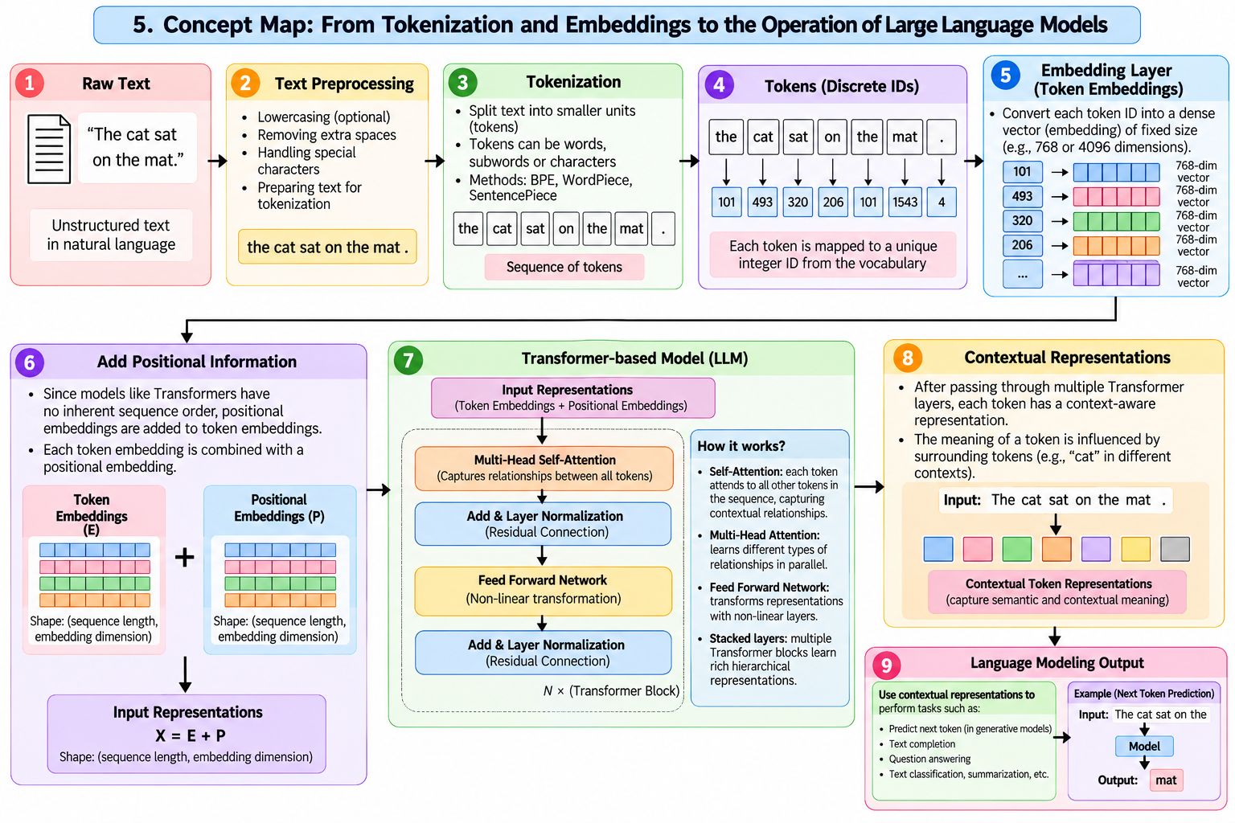

6. Develop a comparative concept map of BERT, GPT, LLaMA, and Gemini. Relate their architectural principles, language understanding/generation capabilities, training or modelling approaches, and representative applications, and identify the conceptual similarities and differences among them.
